The Engineering Project

The idea that children are natural scientists, taking interest in the world around them and trying to make sense of it is a widely recognized and accepted belief. The National Research Council (NRC) (2012) believes that young children can build on these natural tendencies and develop strong scientific competences if they are given the opportunity to explore the world through engaging in inquiry and designing solutions to and solving problems. The National Association for the Education of Young Children has endorsed the position statement on science in early childhood education by the NSTA that focuses on engineering practices. “The National Science Teachers Association (NSTA) affirms that learning science and engineering practices in the early years can foster children’s curiosity and enjoyment in exploring the world around them and lay the foundation for a progression of science learning in K–12 settings and throughout their entire lives” (National Science Teachers Association, 2014).

The following engineering project developed out of one teacher’s interest in exploring young children’s engineering design capabilities.

Phase One-Questions

During Phase One of this project, children were encouraged to
-Share prior knowledge
-Ask questions
-Explore common knowledge experiences
-Decide on an engineering problem

To begin Phase 1 we generated a web that contained our knowledge on engineering design. Phase One lasted for one week.

Some of the knowledge generated for our web included:

-Engineers build space ships
-Everyone is an engineer
-Engineers build airplanes and skyscrapers
-Engineers build and fix problems

We closed Phase one with a decision regarding our engineering design. We would focus on creating a design that would transport water from our porch to the sand box on our playground. The question guiding our inquiry was: How can we get water down to the sand box?

Phase Two-Investigations

Phase two of this project encouraged children to:

-Begin exploring the engineering design process
-Develop knowledge of an engineer’s job
-Observe different types of water transportation systems
-Observe blueprints and create their own design drawings
-Imagine and plan our water transportation system
-Create and build the water transportation system
-Work collaboratively
-Problem solve

During Phase Two the children were introduced to various types of water transportation systems including pipe irrigation systems, aqueducts and pulley systems. Phase two involved multimodal literacy that allowed children to represent their understandings of these ideas using paper and pencil, blocks, clay and painting. They engaged in careful observational drawings of these systems that required close observation and attention to detail.
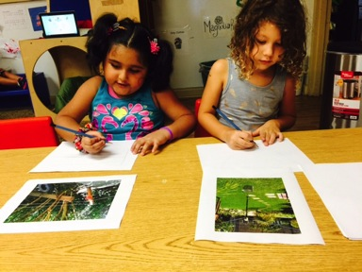

We used large wooden blocks to represent our understanding of these systems by building them three dimensionally.
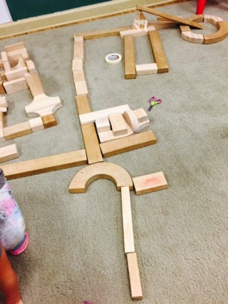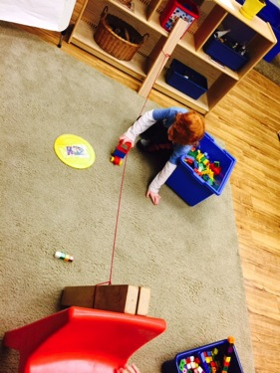

The children molded clay into replicas representing the water transportation system of their choice.

One child was interested in the water pulley system idea. He began by creating two clay supports to attach a clay pulley to. He stated, “this is where the bucket goes when it goes back and forth. The water pours in the sand pit”.
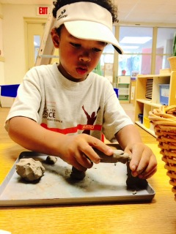

Another used string and popsicle sticks to create a pulley water system. She problem solved and decided to use popsicle sticks as her poles after her clay kept collapsing. She created a bucket by rolling clay, poking a hole in the middle and stringing twine through it. She looped the string around the popsicle sticks. She experimented with the weight of the bucket as it kept pulling the popsicle stick down. She solved the problem by placing the bucket in the middle and looping the extra string around the popsicle sticks until taught.

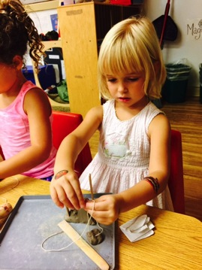

After exploring and understanding how these water transportation systems work, we engaged in discussions about which system would work best to address our engineering design problem-getting water to the sand box. We took a vote and settled on designing and building a pipe system. The children began sketching, building and molding their ideas. We read and used a blueprint map of the playground to design our ideas. We read this map and decided where our pipe would lay and the configuration we would lay it in.

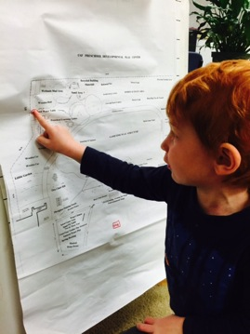

We worked to create a list of the materials that we would need for our design and asked parents for their help collecting the items.

After brainstorming the list of materials that we would need to create our design plan, one child wrote each word out for us. We worked together to sound out the letter sounds for each word as he wrote them.
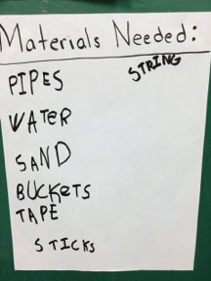

As materials began being delivered, children began experimenting with them.

We problem solved how to arrange two different types of pipes to create one long cohesive pipe system.
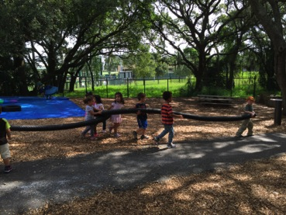

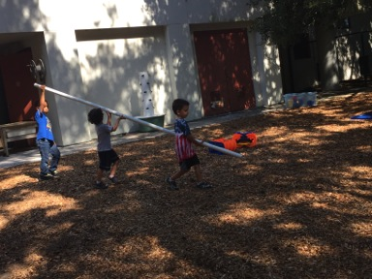

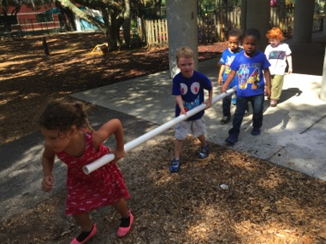

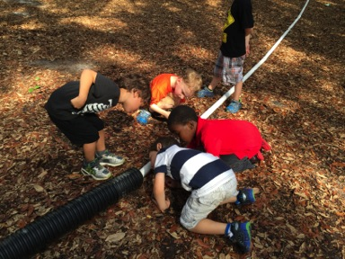
We worked to figure out how to attach the pipe to the ground. A parent helped us problem solve through the process of attaching the pipe to the ground. We began by deciding on creating a trench for the pipe, but after lots of hard work and very little progress we changed our minds and decided on using wire stakes.
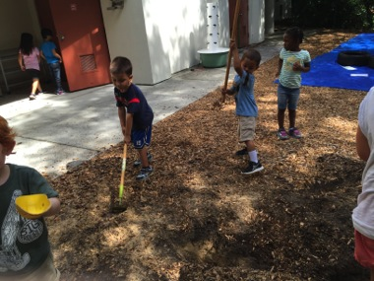

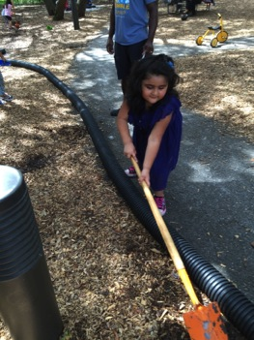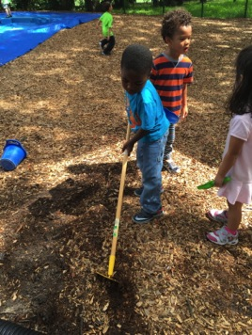

We had to problem solve a way to connect the pipe joints. We decided on using duck tape, and we wrapped the tape around the pipe connections.
This was tricky and involved teamwork.
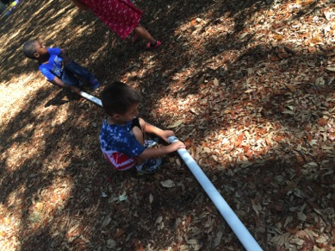

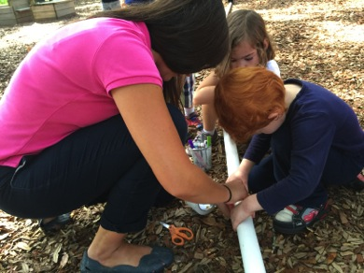

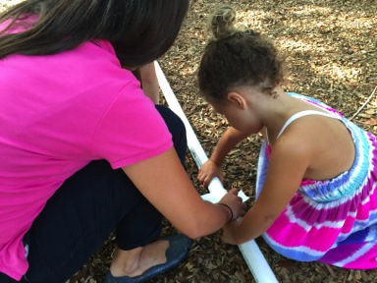

We tested the finished pipe by running water through it. We began by pouring water through a funnel into the pipe and quickly realized that it was not coming out the other side. We measured the length of the pipe and determined that due to the long length of it we would need something that would push the water down through the tube.
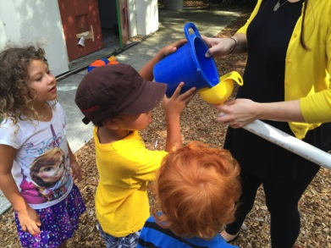
We decided to attach a hose to the pipe and the pressure forced the water down into the pipe and it began to travel through. Now, we encountered the issue of slope. The pipe was flat in areas and the water simply puddled inside it. We experimented with propping the pipe up to create a downward flow.
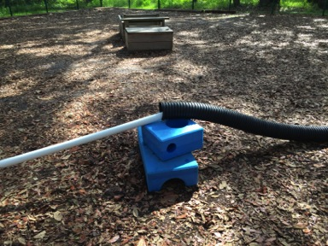
We were so excited when the water flowed into the sand box for us to create sand castles with!
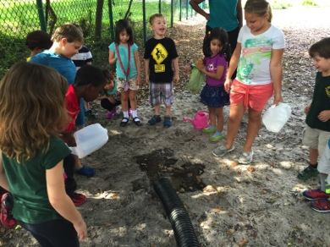

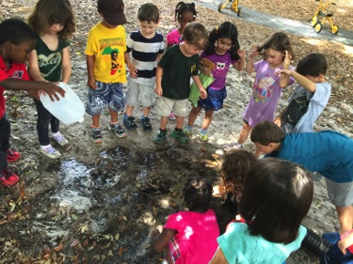
Phase 3-Sharing our Knowledge

This phase of the project encouraged children to:

-Plan and share what we learned
-Communicate
-Celebrate our learning experiences

Phase three involved conversations about how we want to share our pipe with others at our preschool. We decided to unveil the pipe at a water day and introduced our friends to it. We brainstormed rules for the pipe and presented them to everyone and showed them how the pipe works.

